Serial No:
Sessional I
Total Time: 1 Hour
Total Marks: 50
________________
Signature of Invigilator

CS 301 & Theory of Automata

Monday, September 23, 2013
Course Instructor
Dr. Waseem Shahzad and Ms. Mehreen Alam

______________________________ _________ ______ _____________________
Student Name Roll No Section Signature

DO NOT OPEN THE QUESTION BOOK OR START UNTIL INSTRUCTED.
Instructions:
- Attempt on question paper. Attempt all of them. Read the question carefully, understand the question, and then attempt it.
- No additional sheet will be provided for rough work. Use the back of the last page for rough work.
- If you need more space write on the back side of the paper and clearly mark question and part number etc.
- After asked to commence the exam, please verify that you have seven (7) different printed pages including this title page. There are total of 5 questions.
- Use permanent ink pens only. Any part done using soft pencil will not be marked and cannot be claimed for rechecking.

 | Q-1 | Q-2 | Q-3 | Q-4 | Q-5 | Total
Marks Obtained
Total  Marks | 10 | 10 | 10 | 10 | 10 | 50

Vetted By: _____________________________ Vetter Signature: _____________________

Question 1:- Marks 5+5.
a. Give recursive definition of the language Powers of Two.
b. Give recursive definition of the language, defined over the alphabet {a, b}, the language EVENSTRING, i.e. of all words of even length.
Question 2:- Marks 5+5.
Draw the DFA accepting the following languages:
a. (ab + bb)*
b. b* + b*a(ba)*
Question 3:- Marks 5+5.
Determine the regular expression of the language accepted by following FAs.
a.

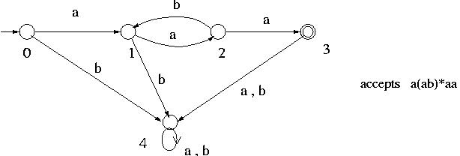
b.

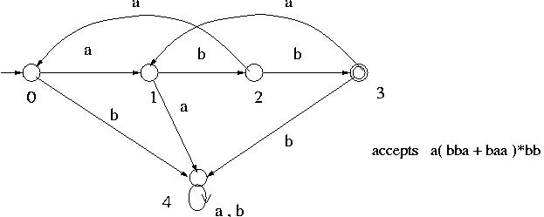
Question 4:- Marks 5+5.

Consider the language over the alphabet = { a,b }

a. Construct a regular expression in which the total number of ‘b’ is divisible by 4 no matter how they are distributed and ‘a’ are only found in clumps that is divisible by 3.
e.g. - b b a a a b a a a a a a a a a b
- a a a a a a b b b b a a a b a a a b b b

b. All strings with even number of b’s
Question 5:- Marks 5+5.

Convert the following TGs to REs. Do show the necessary steps.
a.
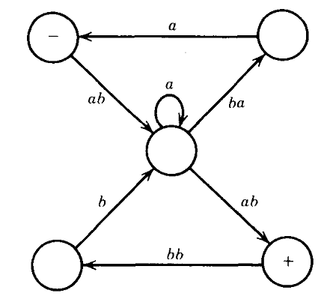
b.
